

**ZTE技术文档英化规范**

ZTE English Documentation Style Guide

修订历史

|  |  |  |
| --- | --- | --- |
| **日期** | **版本** | **修订记录** |
| 2011.12.31 | V1.0 | 初稿 |
| 2012.6.5 | V1.1 | 双语化并经过外籍审核 |
| 2012.9.15 | V1.2 | 修订部分细节错误和互相冲突的地方，对部分内容进行了整合 |
| 2013.8.26 | V1.3 | 增加了语法相关的规定 |

目录

1 序言（Preface） 5

1.1 本规范的读者（Readers） 5

1.2 本规范的目的（Purpose） 5

2 文档英化总则 (General Guidelines) 5

2.1 文档英化质量要求 ( Principles) 5

2.1.1 清晰性（Clarity） 5

2.1.2 准确性（Accuracy） 9

2.1.3 面向任务（Task orientation） 10

2.2 美式和英式英语（American and British English） 12

2.3 编译（Rewriting） 13

2.4 一致性要求（Consistency） 14

3 语法（Grammar） 15

3.1 时态（Tense） 15

3.2 语态（Voice） 15

3.3 语气（Mood） 16

3.4 用户手册中的人称（Person in User Manuals） 17

4 遣词（Wording） 19

4.1 缩略语和缩写词（Acronym and Abbreviation） 19

4.2 冠词（Article） 22

4.3 名词的复数形式（Plurals） 24

4.4 避免多个名词堆砌（Avoid Noun Cluster） 25

4.5 修饰词的顺序（Modifier Sequence） 25

4.6 拼写（Spelling） 26

4.7 复合词的拼写（Compound Word Spelling） 26

4.8 外来词及短语（Foreign Words and Phrases） 27

5 大写规则（Capitalization） 27

5.1 标题大写规则 (For Headings) 27

5.2 表格的大写规则 (For Tables) 28

5.3 图形的大写规则 (For Figures) 29

5.4 专有名词 (For Proper Nouns) 29

5.5 特定标点后的大小写 (After Special Punctuation) 29

6 图形（Figure） 30

6.1 文本要求（Text Requirement） 30

6.2 图名和图引用的要求 （Figure Reference） 30

7 表格（Table） 32

7.1 表格设计（Table Design） 32

7.2 表格中的文字要求（Text Requirement for Table） 33

7.3 表格引用的要求（Table Reference） 33

7.4 参数说明表格（Parameter Description Table） 34

7.5 分支步骤表格（Branch Steps Table） 37

7.6 界面控件、图例介绍表格 （GUI Controls and Legends Tables） 39

8 界面术语（Screen Terminology） 40

8.1 常见界面元素及表达Common Screen Elements and Expressions 40

8.1.1 Windows桌面（Windows Desktop） 40

8.1.2 文件浏览窗口（Open Window） 41

8.1.3 文档窗口（Document Window） 42

8.1.4 网页浏览器窗口（Web Browser Window） 42

8.1.5 窗口元素Window Elements 43

8.1.6 对话框常见界面元素Dialog-Box Elements 44

8.1.7 基于Web的中兴软件界面元素Web Page Elements of ZTE Software 48

8.2 常见界面术语辨析Differences Between Common Interface Terms 50

8.2.1 Screen 50

8.2.2 窗口（Window）与对话框（Dialog Box）的区别Differences Between Windows and Dialog Boxes 50

8.2.3 对话框（Dialog Box）与信息框（Message Box）的区别Differences Between Dialog Boxes and Message Boxes 50

8.3 界面元素前常用介词搭配（Prepositions） 51

9 标点符号 (Punctuation and Space) 51

9.1 中英文标点符号转换约定（Conversion of C-E Punctuation） 51

9.2 常用标点符号（Common Marks） 52

9.3 并列句末的标点符号（Parallel at Sentence End） 54

9.4 表格中的标点符号Marks in Tables 55

10 数字表达 (Digital Expression) 55

11 产品名称（Product Name） 56

12 国际通用单位制 (SI) 57

12.1 英文计量单位和科技术语及缩写（Measurement） 57

12.2 SI前缀（SI Prefix） 61

13 键盘按键约定 61

# 序言（Preface）

## 本规范的读者（Readers）

本规范的主要读者是中兴通讯（ZTE）英文技术文档英化人员。

This style guide is intended for ZTE English Documentation Engineers (EDE).

## 本规范的目的（Purpose）

本规范的设计与编写，主要针对本公司技术文档编译的需求与特点。本规范介绍了英文技术文档的英化导则、遣词、大写规则、图、表规则、界面术语、标点符号、数字表达、产品名称英化及国际单位，旨在提高公司英文技术文件编译的一致性。

This style guide is designed to meet the current requirements for translating ZTE technical documentation. It introduces general requirements, wording, capitalization, figure, table, GUI terms, punctuation, digital expression, product names, and International System of Units (SI), intending to enhance the consistency in ZTE technical documentation.

# 文档英化总则 (General Guidelines)

技术文档英化要求准确地使用技术术语，流畅熟练地运用文体程式，缜密合理地衔接篇章，适当运用修辞手段，使技术文体特点在英化中得以充分地体现。

Use technical terms accurately, comply with the English documentation style guide professionally, organize contents cohesively, and apply rhetorical means appropriately.

## 文档英化质量要求 ( Principles)

技术文档英化的质量应满足清晰性、准确性和面向任务的要求的要求。

要满足这些要求，必须遵循本规范及相关的文档开发规范、工具使用规范，并保持一致性。

Clarity, accuracy, and task orientation are primary objectives of effective technical writing. To meet these requirements, EDEs should follow this style guide, relevant documentation R&D conventions, and tool usage standards to keep the consistency.

* + 1. 清晰性（Clarity）

文档的清晰性是指用户在第一次阅读的时候就能够很容易的理解文档内容，而不需要去分析语法或逻辑关系、解读含混难懂的内容、或猜测和挖掘隐含的意思。

Clear information is information that users can understand the first time. They don't need to reread it to untangle grammatical connections, sort out excess words, decipher ambiguities, figure out relationships, or interpret the meaning. Clarity in technical information is like a clean window through which you can clearly see the subject.

遵循以下方法有助于保证信息的清晰性：

* 使用简洁的语言。
* 用词朴实。
* 主动语态优先。
* 动词优先。
* 定语从句优先。

To make information clear, follow these guidelines:

* Write precisely.
* Use familiar words
* Use active voice preferably.
* Put action in verbs.
* Use an attributive clause preferably.
* **使用简洁的语言（Write concisely）**

多用短句，以使文字简洁。任何主题都可以通过或长或短的信息片段组合起来加以表达。一般而言，短句语义明晰，通俗易懂。

Write concisely with short sentences. Any topic can be described by combining proper-length information units. Generally speaking, short sentences are easy to understand.

过多地使用连词以及过度使用逗号会导致不必要的长句，应尽量避免。应尽量少用括号，并避免繁琐的表达。

Excessive use of conjunctions, commas, and parentheses results in unnecessary long sentences. Avoid complex expressions.

| 繁琐的表达（Complex） | 简练的表达（Simple） |
| --- | --- |
| The product is not of a satisfactory nature. | The product is unsatisfactory. |
| The user can visibly see the image moving. | The user can see the image moving. |
| It is likely that problems will arise with regards to the completion of the specification phase. | You will probably have problems completing the specification phase. |

要避免复杂的句子结构，有些不必要的复合句或复杂结构可以简化。

Avoid complex sentence structures and simplify compound sentences.

| 繁琐的表达（Complex） | 简练的表达（Simple） |
| --- | --- |
| There is a reasonable expectation that . . . | Probably . . . |
| Owing to the situation that . . . | Because . . . |
| Should a situation arise where . . . | If . . . |
| Taking into consideration such factors as . . . | Considering . . . |
| Prior to the occasion when . . . | Before . . . |
| At this precise moment in time . . . | Now . . . |

要精确地表达思想，就必须特别注意同义词和近义词的差别。要选择词义严谨的词，符合专业特征的词，与上下文能匹配的词。

To express precisely, it is important to distinguish between synonyms and synonyms. Use precise, profession-characterized, and coherent words.

译文应完整，其内容和术语应当准确。英化时，应在中文原文的基础上加以理解。英文文字应符合英文的语言习惯，不可生硬的逐字英化。

All versions must be complete, with precise contents and accurate terms. EDEs should understand the original Chinese versions thoroughly before compiling the documents in English. Avoid Chinglish and word-by-word translation.

* **用词朴实 Use familiar words**

要尽量选用词义确切的常用词。只要能用简单的常用词，就尽量避免难的词和短语，更不要用生僻词。

Use simple and familiar words as recommended below:

| 宜少用的单词（Not recommended） | 常用词（Recommended） |
| --- | --- |
| endeavor 努力 | try |
| terminate 停止 | end, stop |
| demonstrate 示范 | show |
| necessitate 有必要 | need |
| utilize 利用 | use |
| facilitate 帮助 | help |
| ascertain 确定 | determine |
| essentially 本质上 | generally |
| portion 部分 | part |
| ongoing 正在进行的 | current |
| commence 开始 | start |

冗长繁琐的短语常可用一个常用词或较简单的短语取代，使得句子结构明晰，语言更加简洁流畅。

Here are examples of wordy phrases and their concise revisions:

| 避免使用（Not recommended） | 建议使用（Recommended） |
| --- | --- |
| a majority of 大多数 | Most |
| a small number of 少数 | a few |
| along the line of 如同 | like |
| are in agreement 同意 | agree |
| as a consequence of 因为 | because of |
| by means of 依靠 | by, with |
| despite the fact that 虽然 | although |
| during that time 那时 | while |
| fall off 下降 | decline |
| for the reason that 因为 | because |
| give rise to 引起 | cause |
| has been shown to be 如此 | is |
| in connection with 关于 | about |
| in respect of 关于 | about |
| in the event that 假如 | if |
| in the vicinity of 靠近 | near |
| is known to be 被认为是 | is |
| it is clear that 明显地 | clearly |
| definitely proved 被证实的 | proved |
| due to the fact that 因为 | because, due to |
| goes under the name of 称为 | is called |
| has the capability of 能够 | can, is able |
| in all cases 总是 | always |
| is in a position to 能，可以 | can, may |
| it appears that 显然 | apparently |
| on account of 由于 | because |
| of great importance 重要的 | important |
| owing to the fact that 由于 | because, due to |
| subsequent to 在...之后 | after |
| through the use of 通过使用 | by, with (not via) |
| was of the opinion that 认为 | believe |

* **主动语态优先（Use active voice preferably）**

详见3.2 语态（Voice）。

* **动词优先 （Put action in verbs）**

在动词和表示动作和行为的名词之间，应优先使用动词，使得意思的表达更为直接清楚，也可缩短句子。直接使用动词而不是使用表示动作的抽象名词，可使结构更加紧凑，表达更加清晰。

A verbal noun is a noun formed from or otherwise corresponding to a verb. One way to write more concisely is to avoid “verbal noun + preposition” pattern. Putting action in verbs makes the syntax of sentences clear.

| 动作和行为名词 Verbal noun + prep. | 直接使用动词 Put action in verbs |
| --- | --- |
| Measurement of static software properties is performed by the tool. | The tool measures static software properties. |
| Clicking the icon causes the execution of the program. | The program is executed when the icon is clicked. |
| The analysis of the software is performed by the analysis unit. | The analysis unit analyzes the software. |
| The testing of the software is carried out by the maintenance personnel. | The maintenance personnel test the software. |
| This method facilitates the utilization of inspection techniques by the testing team. | This method helps the test team use inspection techniques. |

* **句子不复杂的前提下，用定语从句代替现在分词/过去分词作定语（**Use an attributive clause instead of a present participle or past participle if the sentence will not be complicated.）（以使得中心词前前不会有大量的修饰成分）

* + 1. 准确性（Accuracy）

技术文档中的所有信息都必须是准确的，包括概念型信息、事实陈述、过程、图形元素及其他文档细节。英化人员应具备一定的文档开发技能，能够采用最合适方式更恰当组织和呈现信息。

For technical information to be accurate, every piece of information must be accurate, including conceptual information, factual statements, procedures, graphical elements, and other details in the writing. EDE must have a certain level of documentation R&D skills, organize and present the information appropriately.

为了保证信息的准确性，文档英化人员必须：

* 了解最基础的计算机、通讯知识。
* 联系上下文、图示、其它相关文档。
* 与同行、中文作者或SME沟通、探讨。

（Society of Manufacturing Engineers <美>制造工程师学会）

To ensure the information accuracy, EDE should:

* Have basic knowledge of computer science and telecommunication
* Understand context, graphics, and other relevant documents
* Communicate and discuss with CDE and SME
  + 1. 面向任务（Task orientation）

产品文档的目的是为了帮助用户执行任务，因此需要从用户的角度理解文档写作涉及的任务。

Users read the documents to know how to do their tasks. Therefore, EDE needs to understand the tasks from the users' perspective.

为了使技术文档面向任务，英化人员可以采用以下方法：

To make information task-oriented, EDE may follow these guidelines:

* 从任务型Topic的标题上要能够看出其中的内容与任务有关，还要能够看出是什么任务。句式必须采用动名词短语。

Write task topic title, using gerundial phrase that clearly indicates the specific task.

* 任务型信息中适当采用第二人称（参见“3.4 用户手册中的人称（Person in User Manuals）”）或使用祈使句。

Present the task instructions in second person or imperative mood appropriately. Refer to Section 3.6 “Person in User Manual” for more details.

* 操作步骤必须使用祈使句。

Write the operational procedure in imperative mood.

* 复杂的操作要给出操作目的或操作结果。

Describe the purpose and result for complicated operations.

* 合适的时候，与用户的任务相联系。

Keep in line with the user’s task appropriately.

* 介绍产品、技术事实、工作原理的描述型信息（特别是在描述类手册中）中，应避免使用第二人称或祈使句。操作类手册中，介绍用户任务的描述信息可以使用第二人称。

Avoid using second person or imperative mood to write descriptive information on specific product, technical fact, and operation principle (especially in descriptive manuals). Write task procedural manuals in second person or imperative mood.

* 语句的组织应考虑用户的操作顺序、操作环境和条件。例如，地点状语、条件状语应放在步骤的开始。

Organize the context in accordance with the operational sequence, environment, and condition. For example, place the adverbials of location and condition before the step.

* 可选步骤应注明。

Add notes for optional steps.

* 正确使用情态动词，区分使用用户必须执行的操作（Must）和应该执行的操作（Should）。

Use modal verbs correctly. Use *must* only to describe a user action that is required. Use *should* only to describe a user action that is recommended but optional.

操作步骤的推荐写法为：

[条件状语] [时间状语] [地点状语] 操作步骤 [操作目的] [简短的补充信息] [操作结果]

(Optional) [操作目的] [时间状语] [地点状语] 操作步骤 [简短的补充信息] [操作结果]

示例如下：

For operational steps, it is recommended to use the following patterns:

Condition + time + place + operational steps + purpose + brief information + result

(Optional) Purpose + time + place + operational steps + brief information + result

Examples:

In the **XX** area, select **xxx**. The xxx dialog box is displayed, see Figure x-x.

Click **Query all** to display all users. (**句子错误**分开句子，不要写成一句话，写成两句话。)

In the **Path** text box, enter the path and name of the file from which you want to import the template. You can also click **Browse** to select the file.

(Optional) To display the current settings of this link, click **Query**.

(可选步骤和非可选步骤句子写作不一样，注意区分：可选步骤：to…, do…)

## 美式和英式英语（American and British English）

中兴英文技术文档通常采用美式英语。如果产品项目组强烈要求，可根据客户的特定地域或特殊需求采用英式英语。

如果建议、协议和标准中的标题文字或章节名原本采用的是英式拼写，直接引用的时候，不修改原文的拼写。正文仍然沿用美式拼写。

建议、协议和标准中的一般描述文字，如果不是直接引用，即使原来采用的是英式拼写，在非直接引用的句子和章节中改为美式拼写。

In general, ZTE technical manuals are written in American English. If there is a strong request from the product project team, write the manuals in British English according to the regions and requirements specified by the customer.

If topic titles or chapter names in the original proposal, agreement, and standard are spelled in British English, keep them unchanged for direct quotation, but use American spelling for text.

Also use American spelling when writing descriptive text in proposal, agreement, and standard for non-direct quotation, even if the original text is written in British English.

美式和英式英语的拼写区别：

Spelling differences between American and British English:



英化人员可以使用以下两个链接查询具体的范例，作为学习参考。

EDE can use the following two links to query more examples for reference:

<http://esl.about.com/library/vocabulary/blbritam.htm>(已经找到并添加至收藏夹) http://www2.gsu.edu/~wwwesl/egw/jones/differences.htm （未找到）

使用美式英语的国家：美国、菲律宾

学习美式英语的国家：南美洲30%、日本30%、韩国、中国20%。

Countries using American English: USA, Philippines.

Countries learning American English: South America 30%, Japan 30%, Korea, PRC 20%

## 编译（Rewriting）

文档英化工作提倡编译。

编译应该在充分了解原文含义的基础上进行，并遵循文档规范。

Rewriting is essential to producing a high-quality user manual. Rewriting should be based on thorough understanding of the source text, and should always abide by this Style Guide.

英化过程中，应随时关注文档架构及内容是否存在问题。一旦发现明显的架构或内容问题，应第一时间反馈给英化科长，同时暂停任务处理。待有明确结论后，再继续进行任务。

While authoring a manual, the EDE should always pay attention to manual structure and contents. When discovering severe structural or contents flaws, immediately notify the team leader, suspend the task and wait for further instructions from the team leader.

信息删除：

重复的、多余的信息可以删除。重复是指简单重复；为了提醒读者注意对重要信息的重复不能删除。多余的信息是指对于目标读者无用的信息。

简单重复信息的删除，是文档英化人员应该具备的技能。大段多余信息的删除属于文档开发技能，超出了文档英化岗位的一般性技能要求，应谨慎操作或事先与原作者或文档架构师沟通。

Information Deletion

Delete any needless repetition and redundant information, but retain the appropriate repetition of important information that reminds the user.

It is required that EDE consults the opinion of CDEs or IAs before deleting any paragraph-sized information, which is beyond the skill requirement for EDE post.

信息修改：

修改信息的目的应该是提高文档质量（准确性、清晰性和面向任务等），涉及选词、句式、语言表达方式、信息呈现方式等，是文档英化人员最需要提高的能力。

Information Revision

Information revision aims at developing quality technical information (accuracy, clarity, task orientation). It involves wording, sentence pattern, language expression, and information presentation. EDE needs to improve such skills for information revision.

信息补充：

词语、短语、句子层面的信息补充是文档英化人员能够提高的技能。

如发现大量必需内容缺失，应第一时间反馈给英化科长。

Information Addition

When developing information, look for logical holes, areas where some information might be missing. It is required that EDE adds words, phrases, and sentences (not paragraphs) logically to include enough information in the documents.

When the EDE deems that a paragraph/section/chapter is redundant and useless, immediately report the problem to the team leader.

## 一致性要求（Consistency）

一致性要求是对文档英化工作的要求，不属于质量要求但影响文档英化质量。英文技术文档的一致性包含以下几个方面：

Consistency in both style and technical accuracy are extremely important and of the highest priority. It includes:

**外观和感觉：**

所有手册呈现给用户的外观和感觉必须类似。同种类型的手册呈现给用户的外观和感觉必须完全一致。更新的文档要尤其注意。

Look and Feel

All documents must have a similar look and feel to them and each particular document type should have the same look and feel as all other documents of the same type.

**设备及功能的名称：**

所有手册中对产品及其功能的描述必须一致。产品、功能、软硬件模块、单板、指示灯、控件等各种元素的物理或逻辑名称必须一致。

Equipment and Function Name

If a function is being described, it must always be referred to by the same name. This also applies to equipment including hardware components such as modules or chassis and also to switches, circuit breakers and indicators.

**技术数据：**

同一产品的所有技术手册，必须提供统一的技术数据。如果一本技术手册里更新了技术数据，那么同样产品的其他技术手册中，也应该更新该数据。

Technical Data

All technical data matches from one document to another when those documents are describing the same equipment. If specific data on a product is included in one document covering a particular piece of equipment that data must match the data elsewhere in the document and in all documents on that same equipment.

# 语法（Grammar）

为了更好保证技术文档的清晰性、准确性和面向任务；技术文档有自己的语法要求，主要体现在时态、语态、语气等方面。

## 时态（Tense）

以一般现在时为主。

Write in the simple present tense whenever possible.

**Incorrect:** When you press the **Restart** button, the system will run a self-test. If the system fails self-test, the processor will not reboot the operating system.

**Correct:** When you press **Restart**, the system runs self-test. If the system fails self-test, the processor does not reboot the operating system.

很少情况下，基于现在时所确定的“时间”需要采用过去时、完成时或将来时。

Consider how your use of present tense establishes a sense of time, and use past or future tense only with respect to the present time as you have established it.

**Correct:**

Delete a user name if you are sure that this user name will never be used.

If you selected **New** at the previous step, the current window displays the recommended default values.

如果后续动作和当前的动作之间有较长的时间间隔，后续动作可以用将来时。

**Correct:**

Power off the device and remove the power plug if you will not use it for a long time.

较长一段时间之后才会再次使用设备。

If you select **Auto Start**, the system will restart automatically after you finish the installation.

System restart是在当前Select操作较长时间之后发生的（需要等待整个安装任务完成），因此Restart用将来时。

告警、通知、日志等信息描述已经发生或者在过去发生的事件，可以使用完成时或过去时。

## 语态（Voice）

主动语态有助于明确动作的执行者。技术文档中应以主动语态为主。

在以下情况下可使用被动语态：

* 为了避免用词累赘或拗口。
* 动作执行者不明确或显然是指该系统，或需要强调动作的接受者。
* 主语指用户，主动语态看起来像是埋怨用户的时候，特别是在错误信息和故障处理信息中。

In active voice, the person or thing performing the action of the verb is clear. In general, active voice should predominate.

It is all right to use passive voice in any of the following conditions:

* To avoid a wordy or awkward construction.
* When the subject is unknown or obviously the system, or the emphasis is on the receiver of the action.
* You want to avoid blaming the user for an error, especially in error messages and troubleshooting content.

**Preferred:**

Active voice:

This version includes many new features.

You can divide your documents into as many sections as you want.

Passive voice:

Click **Edit**. The **Edit Attribute** dialog box is displayed.

**Avoid (passive voice):**

Many new features are included in this version.

Your document can be divided into as many sections as you want.

## 语气（Mood）

技术文档中语气的使用应遵循以下规则：

* 陈述语气：用于描述事实或解释说明。
* 祈使语气：用于指导或要求读者执行某个操作。隐含主语为第二人称。祈使句只用于现在时。操作步骤必须使用祈使句；但祈使句不是只用于操作步骤。
* 虚拟语气：技术文档中尽量避免虚拟语气。（虚拟语气用于表达希望、猜想以及与事实相反的条件。）

例如It is suggested、It is important等构成的虚拟语气通常可以用should、must等代替。It is recommended例外，可以使用。

* 同一段落中不要转变语气。

Follow these guidelines to choose the appropriate mood:

* Use the indicative mood to express general information such as facts and explanations.
* Use the imperative mood to instruct or request the reader to do something. The subject *you* is implied. Use the imperative mood in (but not only in) procedures. Use only the present tense with the imperative mood.
* Avoid the subjunctive mood in technical documentation.
* Do not shift from one mood to another in the same paragraph.

**Preferred (indicative mood):**

You should complete this procedure before taking any other action.

**Avoid (subjunctive mood unnecessary):**

It is important that you complete this procedure before taking any other action.

**Correct:**

Enter a file name, and then click **OK**.

**Incorrect:**

Enter a file name, and then you can click **Bold**.

The first step is to enter a file name, and then click **OK**.

## 用户手册中的人称（Person in User Manuals）

不要使用he, she, 不要使用表示目标读者或ZTE、作者。使用ZTE指代本公司，不要用we和I。

Do not use pronoun s*he* or *she*. Do not use *they* to stand for intended audience, and do not use *we*, *I*, *me*,*us* to stand for ZTE or the author.

可以用第二人称you，you指文档的读者。如果是让读者执行某个动作，建议直接用祈使句。

You主要用于操作类、故障处理类手册中，包括其中介绍任务的描述型topic。纯粹的描述型手册（如产品描述、硬件描述）中不建议使用。

The second-person pronoun “you” can be used for user-related actions. Using *you* is useful in order to involve the reader in describing an instruction. The over tendency of “trying” to insert it, however, is detrimental and most of the time results in grammatical error.

It is recommended to use *you* in operation guides and troubleshooting guides, including the descriptive topics that provide task information. It is recommended not to use *you* in descriptive manuals such as Product Description and Hardware Description.

Example 1

**Incorrect:** The important sites that you concern most have been set as XYZ sites, ABC sites, or 123 sites according to the priorities.

**Correct:** The related sites have been set as XYZ sites, ABC sites, or 123 sites according to the priorities.

(Note that if something is “related” to an operator’s work, both importance and relation can already be implied.)

Example 2

**Incorrect:** If three XYZ modules and six ABC boards are to be configured, you allocate each XYZ with two ABC boards.

**Correct:** If three XYZ modules and six ABC boards are to be configured, allocate each XYZ with two ABC boards.

Example 3

**Incorrect:** Run the **routeshow** command to view the routing table after you add a route.

**Correct:** Run the **routeshow** command to view the routing table after a route is added.

Example 4

**Incorrect:** If you do not press any key in three seconds, the system automatically loads the version saved in the flash.

**Correct:** If no key is pressed within three seconds, the system automatically loads the version saved in the flash.

User指设备使用者。如果用户就是文档的读者，优先选用you。如果用户的使用者所代表的对象不是文档的读者，比如说，某些手册中所说的“用户”不是指中兴的客户，而是中兴客户的用户（或客户），也就是不是中兴的直接用户（或客户），就只能用user或subscriber，不能用you。

Use user to refer to the equipment user. If the user is the reader of the document, it is recommended to use you to refer to the reader (user). If the "user" is not the reader, for example, "users" in some manuals are not customers of ZTE, but subscribers of a ZTE customer. In this case, use user or subscriber to refer to the reader.

Subscriber是签约用户（即与运营商、服务提供商之间有签约关系）。有的终端用户是subscriber，如手机用户。有的终端用户不是subscriber，如家用路由器、交换机的用户。

Use subscriber to refer to the service subscriber of a Service Provider. Some terminal users are subscribers, such as mobile users. Some terminal users are not subscribers, such as users of routers and switches.

介绍产品、技术事实的描述型信息（特别是在描述类手册中）中，应避免使用第二人称或祈使句。操作类手册中，介绍用户任务的描述信息可以使用第二人称。

Avoid using the second person (you) or imperative sentences in descriptive manuals that provide product or technology information.

# 遣词（Wording）

英文技术文档的简明性主要体现在用词特别是动词和名词的语义简明、确切，强调词义的单一性和结构简明。英化技术文档时，要注意用词准确，语义确切。

The conciseness of English technical documentation primarily depends on wording, especially verbs and nouns. Each word has a concise definition and only one meaning.

## 缩略语和缩写词（Acronym and Abbreviation）

**缩写词**

缩写词（abbreviation）是某个词汇的缩写形式。除了计量单位、公认的专业术语、专有名词等，技术文档中不建议使用缩写词。

缩写词的不定冠词取决于其原形词。

**缩略语**

缩略语（acronym）由词组的首字母或关键字母构成，有些可以连读成词。

An acronym is made up of the first or key letters of words. Some acronyms can be pronounced as a word.

Example: Local Area Network（LAN）

**缩略语的写法：**

The first letter of each word defining an acronym should be capitalized and added as shown in the following examples:

Loss of Signal (LOS)

Loop-Back (LPBK)

Note: Do not capitalize a letter within a word but only the first letters of words, even if part of the acronym letters are part of the word as in done in the following examples:

Do not do this: RSVP – ReSerVation Protocol

Do this: RSVP – Reservation Protocol

缩略语的不定冠词的选择取决于这个词的发音。

例：an LED

例：a LAN （因为LAN是可以连读发音的，且是辅音开头）

An abbreviation is a truncated word. Except for units of measurement and those in well-known terminologies and proper nouns, abbreviations are not recommended in technical documentation.

Examples: Dr. (Doctor), bldg (building)

The indefinite article for an abbreviation depends on its spelled-out form.

The indefinite article for an acronym depends on its pronunciation.

The article for an acronym depends on the pronunciation of the acronym.

Examples:

an LED

a LAN (LAN is pronounced as a word and begins with a consonant)

**缩略语的单复数**

把缩略语视作普通名词。对缩略语和缩写词的复数形式，一般直接在其后面加小写的s：

例：You can send FAXs to verify your reservation.

Plural of acronyms

Acronyms are regarded as ordinary nouns. If an acronym is defined as a singular noun, add a lower-case “s” to the end when it refers to the plural.

Example: You can send FAXs to verify your reservation.

**在标题中的使用**

标题中尽量使用缩写形式，并在就近的正文中对此缩写形式给出全称。

Acronyms and abbreviations in titles

Use the abbreviated form of acronyms in titles if possible, and spell them out in the following text.

在WORD、EXCEL、PPT文档中，首次出现一个专门术语时，要先给出全称，其缩略语放在随后的括号中。文中再次出现此专门术语时，可以直接采用缩略语代替。

In a Word, Excel or PPT document, spell out an abbreviation or acronym on its first occurrence, with the abbreviation or acronym in parentheses. Then continue using the abbreviation or acronym alone.

在XML 格式的topic文件中，一个缩略语在一个Chapter中首次出现时，要先给出全称，并将缩略语放在随后的括号中，做缩略语链接（使用gxref标签）。

In XML topic documents, spell out an abbreviation or acronym on its first occurrence in each chapter, with the hyperlinked (using the **gxref** tag) abbreviation or acronym in parentheses.(在第二个章节重新出现要再次给出全称吗)

以下情况下，即使第一次出现也可以不给出全称，但应给出缩略语链接：

* 目标读者熟知的缩略语。使用缩略语更容易理解，而给出全称影响理解，比如一个句子中有多个缩略语。
* 缩略语比全称更为广泛了解，如HTML、MAC address。
* 空间太小，例如在表格中或图形上。
* 在有很多数值的文字中。
* 在表格中，缩略语全称可以在表注中给出。
* 标题中，全称可就近的正文中给出。
* 缩略语编号等成为一体，如EIA RS232。（是目前最常用的一种串行通讯接口）

Use an abbreviation or acronym only with a gxref link in the following situations:

* Do not spell out an abbreviation or acronym that is commonly known to the target audience.
* Where the meaning is clear and it benefits the user by making the information easier to comprehend
* Where it is recognized more easily than its spelled-out form, for example, HTML
* Where space is limited, for example, in a column in a table or in a detailed diagram
* In text that deals mainly with dimensions and other numeric specifications
* In tables, where the abbreviation or acronym can be explained in the table note
* In titles, where the abbreviation or acronym can be explained in the text nearby
* Where the abbreviation or acronym and numbers or other letters form a proper noun, for example, EIA RS232.

**可以省略全称的缩略语**

文档开发部开发的基于topic和xml的文档，缩略语参照中文。中文文档中若省略了全称，则英文文档中相应省略，不必刻意添加。

产品、读者不同，熟知的缩略语也会不同。因此各文档团队应该确定哪些缩略语是本团队文档的读者所熟知的。在中兴通讯的任何运营商用户文档的正文中，以下缩略语的全称均可以省略（手机等终端用户的文档中除外）：

Commonly known terms vary by product and by audience; therefore, each documentation team should determine which abbreviations the audience knows. Spelled-out forms of the following abbreviations can be omitted in the main body of any ZTE user manual for carriers (except those for end users):

| **HTML** | **CDMA** | **FTP** | **TCP** |
| --- | --- | --- | --- |
| **IP** | **URL** | **XML** | **WWW** |
| **IEEE** | **DOS** | **HTTP** | **LAN** |
| **WLAN** | **GUI** | **MAC** | **WiFi** |
| **VCD** | **DVD** | **CD** | **VGA** |
|  |  |  |  |

**不宜使用缩略语的情况**

以下情况下，避免单独使用缩略语：

* 一章中同一个缩略语有多个含义，如FE （Front End和Fast Ethernet）。出现频率低的应在各处给出全称或直接使用全称。
* 缩略语的含义与目标读者所熟知的含义不同，且使用的场合容易造成误解。如IP作为“智能网外设”不如“因特网协议”被读者所熟知。
* 普通含义的词（即不是专业术语、专有名词、界面词引用等），且不需要节约空间，如OS （operating system）、HD （hard disk）。
* 文档中极少出现，如只出现一两次。
* 缩略语已经被其他公司注册为商标，如3G。

Avoid using abbreviations or acronyms alone in the following situations:

* One abbreviation or acronym in the same chapter has multiple definitions, for example, FE (Front End, Fast Ethernet). The less used abbreviation or acronym should be fully spelled out or directly replaced with the full form.
* The meaning of an abbreviation or acronym is different from that of the well-known one, and is easy to be misunderstood in the context. For example, the IP for Intelligent Peripheral is not well-known than the IP for Internet Protocol.
* A phrase with a common sense as its words indicate, such as **operating system.**
* The abbreviation or acronym is seldom used in a document.
* The abbreviation or acronym is registered as a trademark of a company, for example, 3G.

## 冠词（Article）

冠词分类

不定冠词是a 和 an ，定冠词是 the。

Indefinite articles include *a* and '*an* while definite article includes *the*.

界面元素之前的冠词使用

界面元素，如窗口、菜单、选项、按钮（称之为属性词）等，如果有属性词和名称，则在其名称前需加定冠词the。如果只有名称，但无属性词，则不加冠词。

Use the article *the* before the names of interface elements such as windows, menus, options and buttons (which are called interface property names). Do not use any article for element names without property names.

例如：

Click the **XX** button. 或者Click **XX**.

Click **XX**. The **xx** tab is displayed, see Figure 1-1.

Examples:

Click the **XX** button.

Click **XX**.

The **xx** tab is displayed, see Figure 1-1.

应该使用定冠词的情形

在书名、手册名称等之前，需要使用定冠词。

Use the article the before the name of a book or user manual.

Example:

For more information about the EMS GUI, refer to the *EMS User Guide*.

标题中的定冠词和不定冠词，用法和句子中的保持一致。

Usage rules for the articles in titles are the same as those in text.

Examples:

Launching the Network Configurator

Defining a Bootstrapped Node

在产品名之前，需要使用定冠词。

Use the article the before a product name.

Examples:

the ZXMP S385

the NMS

the LMT software

在following, current, corresponding, specified, same等词之前，一般需要使用定冠词。例如：

Use the article the before particular words such as following, current, corresponding, specified, same.

Example:

Observe the following instructions to avoid exposing yourself and others to risk: ...

不要定冠词的情形及例外

不要用The做为以下几项的句首单词。

Do not use **the** to begin any of the following items:

Manual titles

Chapter titles

Headings

Figure captions

Table captions

Callouts

在状态（status，state），模式（mode），格式（format）之前，不需要使用冠词。

例如：

Note that no article is used for status (state), mode and format in the following examples:

Make sure that the work and protection cards are in normal status.

In administrator mode, you can deploy and maintain applications.

This contains ten files in .xls format.

以下情况属于固定搭配，仍然需要使用冠词：

Note the use of article in the following examples:

Enter the year in a four-digit format.

Date to search for in the format of YYYYMMDD or blanks

## 名词的复数形式（Plurals）

缩略语的复数形式（Plurals of Acronyms）

直接在缩略语的后面加s。

Add s to form the plural of acronyms.

Example: multiple BBUs

单个字母的复数形式（Plural of A Single Character）

To form the plural of 0, 1, A, E, I, O, U, M, S, or lowercase letters, add 's. Adding s alone to any of these characters produces a combination that might be confused with a word or common abbreviation (such as Is, as, Ms, or us).

Example: 0’s, 1’s, A’s, E’s.（lowercase letters 小写字母；BBSs）

To form the plural of a single character (except 0, 1, A, E, I, O, U, M, S, and lowercase letters), add s alone.

Example: Bs, Cs, Rs.

## 避免多个名词堆砌（Avoid Noun Cluster）

一般情况下，相互修饰的名词最多不要超过4个。

Usually, avoid a noun cluster with more than four nouns.

**原文：**ZXPDSS A100 Radius配置维护系统数据库连接界面

**Incorrect:** ZXPDSS A100 Radius configuration maintenance system database connection interface

**Correct:** Database connection interface of the ZXPDSS A100 Radius configuration maintenance system

## 修饰词的顺序（Modifier Sequence）

一般的顺序为：1）限定词（冠词/代词/数词）→ 2）性质 → 3）大小/形状/新旧/年龄/颜色 → 4）名词性定语（包括动名词）→ 5）名词。

Follow the modifier sequence: 1. Definitive words (article/pronoun/numeral) → 2. Properties → 3. Size/shape/new or old/age/color → 4. noun attributes (including gerund) → 5. Nouns

**原文：**C190移动通信直放站是CDMA移动通信混合组网的重要组成部分

**Incorrect:** The ZXRPT C190 Mobile Communication Repeater is an important part for constructing a CDMA mobile communication hybrid network.

**Correct:** The ZXRPT C190 Mobile Communication Repeater is an important part for constructing a hybrid CDMA mobile communication network.

修饰成分应尽可能的靠近被修饰的主体。如果有多个修饰成分，可能会造成误解的可以放在句首或括号中。

Modifiers should be placed near the modified object if possible. If there are multiple modifiers, place the modifier that is subject to misunderstanding to the beginning of the sentence or in parentheses.

**Ambiguous:** Click the configuration server to which you want to link the list manager servers in the **Configure Server Name** field.

**Clear:** Click the name (in the **Configuration Server Name** field) of the configuration server to which you want to link the list manager servers.

In the **Configuration Server Name** field, click the name of the configuration server to which you want to link the list manager servers.

动词的修饰语（状语）应靠近所修饰的动词。

The (adverbial) modifier for a verb should be close to the verb.

**Ambiguous:**  DHCPv6 is used for a network host to request a host configuration **dynamically** from a server.

**Clear:**  DHCPv6 is used for a network host to **dynamically** request a host configurationfrom a server.

操作步骤中的条件状语、地点状语放在句首。

In procedural descriptions, put the adverbial modifier of condition or place at the beginning of the sentence.

Only几乎可以修饰句子的任何成分，位置不同，含义则不同，如下：

The word *Only* can modify any component of a sentence, with a variety of meaning depending on its position in the sentence. Examples:

| Only an administrator can open the XML files in the latest browser.  An administrator can only open the XML files in the latest browser.  An administrator can open only the XML files in the latest browser  An administrator can open the XML files only in the latest browser. |
| --- |

这两个的区别。

## 拼写（Spelling）

中兴英文技术文档通常采用美式拼写。

具体项目文档根据客户群的特定地域或特殊需求来确定采用美式还是英式拼写。

请参见“*美式和英式英语（American and British English）*”。

Use American English spelling in ZTE documentation.

In documentation for a particular project, determine whether to use American or British English spelling based on the requirement of the project.

For more information, refer to *美式和英式英语（American and British English）*.

## 复合词的拼写（Compound Word Spelling）

复合词拼写的基本原则是：如果不会产生任何歧义，可以不用连字符；如果有可能产生歧义，不管复合词的位置在名词前面还是在名词后面，都必须使用连字符。

The basic principle is that no en dash is required if the compound word does not create ambiguity. If the compound word is ambiguous, use an en dash no matter the word is before or after a noun.

Examples:

high-level language

built-in device

当两个词一起构成复合词修饰另一个名词时，如果复合词中之中有一个词是分词形式，两个词之间应加连字符。

When a two-word compound acts as a modifier of a noun, if one word of the compound is a participle, use an en dash between the two words.

Examples:

copy-protected file

free-moving graphics

## 外来词及短语（Foreign Words and Phrases）

避免使用外来词及短语，例如de facto 或ad hoc 等。

Avoid non-English words and phrases, such as *de facto* or *ad hoc*, even if you think they are generally known and understood. They may not be, or the language may not be understood by a translator. Find a straightforward substitute in English instead.

不要使用拉丁文缩写词表示常用英语短语。

Do not use Latin abbreviations for common English phrases.

避免使用 推荐使用

e.g. for example

i.e. that is

viz. namely

ergo therefore

# 大写规则（Capitalization）

## 标题大写规则 (For Headings)

总体原则：一到三级标题每个实词的首字母大写，并且第一个和最后一个单词的首字母大写。具体描述如下：

The general principle is that the initial letter of each content word in headings should be capitalized, and the initial letters of the first and last words in a heading should be capitalized.

名词、动词、副词（包括than和when）、形容词和代词采用首字母大写。

Nouns, verbs, adverbs (including than and when), adjectives and pronouns should be capitalized in headings

Example: Love Is Just a Four-Letter Word

除了构成动词短语外，少于四个字母的介词采用小写；四个或多于四个字母的介词采用大写。

Except for being used in a verb phrase, a preposition of less than four letters should be lowercased. Capitalize the first letter of a preposition of four or more letters.

Examples:

Campus Without Walls

Campus With Walls

标题的首个单词和最后一个单词的首字母要大写。

Capitalize the initial letters of the first and last words in a heading.

Example: Rules to Abide By

作为动词短语有机组成部分的介词（也就是说，用或不用这个介词，动词短语的意思会大相径庭），其首字母也要大写。

The proposition necessary in a verb phrase should also be capitalized.

Example: Looking For Text

复合词的大写方式，在标题中，如果词的两个部分都是实词，那么前后两部分的首字母都应该大写，例：High-Level

For the capitalization of a compound word in headings, if both words of the compound are content words, capitalize the initial letters of the two words.

Example: High-Level

如果后面一个是数字或虚词，就小写。

If the second word is a form word or number, do not capitalize the word.

Examples:

Build-in

Evaluation of Twenty-one。

## 表格的大写规则 (For Tables)

表名（Table Title）和表头（Table Heading）的大写规则，参见“5.15.1 标题大写规则 (For Headings)”。

For the capitalization of table titles and table headings, refer to “5.15.1 标题大写规则 (For Headings)”.

表中文字采用第一个单词的第一个字母大写，其余小写（专有名词或缩略语除外）。

Capitalize the first letters of content words in table titles and table headings, and capitalize the first letters of the first and last words.

## 图形的大写规则 (For Figures)

图名（Figure Title）的大写规则，参见“5.15.1 标题大写规则 (For Headings)”。

For the capitalization of figure titles, refer to “5.15.1 标题大写规则 (For Headings)”.

图中文字（包括所有流程图，组网图，以及图注中的内容）采用第一个单词的首字母大写，其余小写（专有名词或缩略语除外）。

Capitalize the first letters of content words in figure titles and figure headings, and capitalize the first letters of the first and last words.

## 专有名词 (For Proper Nouns)

地名一般是专有名词，其首字母大写。

Capitalize the first letters of place names, which are generally proper names.

例如：Europe, India, Heilongjiang

Examples: Europe, India

公司、机构的各部门和分部的全称中，实词首字母大写。

Capitalize the first letters of content words in the full name of a department or branch of a company or organization.

例如：Customer Service Department, ZTE Corporation

Example: Customer Service Department, ZTE Corporation

协会和会议的全称的实词首字母大写。

Capitalize the first letters of content words in the full name of an association or conference.

例如：Electronic Industries Association (EIA)

## 特定标点后的大小写 (After Special Punctuation)

在冒号后面：如果冒号后面为专有名词或完整的句子，则首字母大写，其他情况一律首字母小写。

After a colon: Capitalize the first letter of a proper noun or a complete sentence after a colon.

Example: Only a few years later, those same people made sure they had three things when they left their homes in the morning: their wallets, their keys and their cell phones.

在破折号后：首字母一律小写（除专有名词外）

Do not capitalize the first letter of the first word (except for a proper noun) after a colon.

Example: The company estimates that half of its subscribers to the WIN service are new customers - many of them are high-end users from their competition.

# 图形（Figure）

## 文本要求（Text Requirement）

文本应该在符号框，不可超过符号框范围。

字体大小不得大于正文文字，且在显示比例100%的情况下，字体必须清楚可辨。

图中文字采用Arial字体。

字体不能压线。

禁止在图形中出现中文字体。

如果图形中部分说明文字过长，或图形较复杂，可以在图中采用序号标注，在图下说明各序号对应注释。

设备名称使用规定的英文缩略语。如无对应的缩略语，则使用全称。

图中文字采用第一个单词的首字母大写，其余小写（专有名词或缩略语除外）。

All texts must be in boxes and must not exceed the boundaries.

The text size should not be larger than the body text, and must be clearly readable when the zoom control is 100%.

The texts should in Arial font.

The texts must not contain any Chinese characters.

If there are too many words or the figure is very complicated, serial numbers instead of texts can be used in the figure, with the text for each serial number listed in the figure note.

Device names can use standard acronyms if there are any.

Besides proper nouns and acronyms, only the initial character of each sentence or phrase must be capitalized.

## 图名和图引用的要求 （Figure Reference）

**通用要求**

除了参考类手册中特定的一些图，所有图都必须有标题、编号，例如Figure 1-1 Real-time Query Conditions Dialog Box。

所有图在正文中都必须有引用。图提供支撑数据，只有通过引用，用户才能够迅速、准确的找到这些数据。

对图的引用，文字描述应为“see Figure X-X”。引用必须采用链接的形式，不论图与文字有多近或多远。怎么链接

Except some special figures in a reference manual, all Figures must have a number such as Figure X-X, and a title, such as Figure 1-1 Real-time Query Conditions Dialog Box.

All Figures must have a reference to them within the body of the text. Figures are supporting data and will not be reviewed by the user unless they are referenced somewhere within the text body.

When referencing Figures the text should read as follows: “see Figure X-X”. The reference must be a hyperlink to the figure, regardless of how close or far the figure is originally located to the reference. In product or technical description information, “Figure x-x shows…” is also acceptable. The following figure shows an example:

在产品描述、技术描述类topic里可以使用Figure x-x shows，如：

In product or technical description information, “Figure x-x shows…” is also acceptable, for example:

Figure x-x shows the system architecture.

**复杂图名的要求**

对于相同图题但内容不同的多个图形，图名可采用“界面名称+功能”或“界面名称+Tab名”的形式，中间用长破折号分隔（两边不加空格），如下所示：（Tab页签）

Figure 1-1 Edit Attribute Dialog Box—Device Setting

Figure 1-2 Edit Attribute Dialog Box—Address Setting

Figure 2-1 Query Active Alarms Dialog Box—Location Tab

其中“功能”部分比较灵活，可以是动名词或名词短语。

注：不局限于“功能”，也可以是结果描述等，如：

Figure 2-2 Query Active Alarms Dialog Box—Query Result

Figure 2-3 User Management Dialog Box—User Added

**复杂图名的引用要求**

界面第一次出现时，正文引用中应给出该界面的标题（如The Query Active Alarms dialog box）。根据需要，确定是否给出初始显示的Tab名称（the Location tab）或功能描述。界面元素引用名称要和图名中的一致；功能描述部分语法结构可以和正文引用不一致，但之间的关系要显而易见（如Address Setting与for setting the address）。

顺序接下来的描述中，界面的标题可以省略；如下所示：

| Steps   1. On the menu bar, select **Fault** > **Query Active Alarms**. The **Query Active Alarms** dialog box is displayed with five tabs. By default, the **Location** tab is displayed, see Figure 2-1.   **Figure 1-1 Edit Attribute Dialog Box—Device Setting**  …   1. Click the **Alarm Code** tab. The **Alarm Code** tab is displayed, see Figure 2-2.   **Figure 2-2 Query Active Alarms Dialog Box—Alarm Code Tab**  … |
| --- |

| Steps  …   1. Click **Edit**. The **Edit Attribute** dialog box is displayed, see Figure 1-1.   **Figure 1-1 Edit Attribute Dialog Box**  …   1. Setthe device parameters, and click **OK**. The dialog box for setting the address is displayed, see Figure 1-2.   **Figure 1-2 Edit Attribute Dialog Box—Address Setting**  … |
| --- |

# 表格（Table）

## 表格设计（Table Design）

同一表格尽量在同一页显示。如不能在同页显示，则跨页标题行重复。

全文表格颜色不要超过三种，尽量在两种以内。

一页中有多个表时，表格的宽度要求一致：左右与正文的左右对齐，最宽不能超过版面宽度。

表格不能用图片来表示。

A table should be on the same page if possible. If it is not possible, the header line should be repeated.

No more than three colors should be used in one table. It is better if no more than two colors are used.

If more than one table is on the same page, the width of each table should be the same, with the left and right edges aligned with the body text and the maximum width no more than the page width.

A table must not be an image.

## 表格中的文字要求（Text Requirement for Table）

单元格如果是空的，没有内容，应写上连字符（-）。

多个单元格内信息相同时，应重复书写，而不能用“同上”、“同左”等字样。

表头统一采用单数，大写规则跟标题的大写规则一样，参见“5大写规则（Capitalization）”一章。

单元格对齐方式：左侧顶部对齐， 与AE表格属性用词一样，分页时也不受影响。

举例：

Use a hyphen to indicate an empty cell in a table.

If the contents in two cells are the same, repeat the contents, and do not use “ditto”, “the same as stated above” or any other thing similar.

For nouns in the header line, use their single-forms. The header line uses the same capitalization as titles, refer to “5大写规则（Capitalization）”.

Table alignment: left and top alignment

Example:

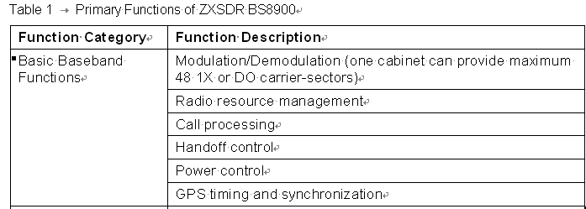

## 表格引用的要求（Table Reference）

除了因特别需要而采用的简单表，所有正式表都必须有标题、编号，例如Table 1-1 Real-time Query Conditions Parameters。

所有正式表在正文中都必须有引用。表提供支撑数据，只有通过引用，用户才能够迅速、准确的找到这些数据。

对表的引用，文字描述应为“For …, refer to Table X-X”。引用必须采用链接的形式，不论图与文字有多近或多远。

All formal tables must have a number such as Table X-X, and a title, such as Table 1-1 Real-time Query Conditions Parameters.

All formal tables must have a reference to them within the body of the text. Tables are supporting data and will not be reviewed by the user unless they are referenced somewhere within the text body.

When referencing Tables the text should read as follows: “For …, refer to Table X-X”.

The reference must be a hyperlink to the table, regardless of how close or far the table is originally located to the reference.

## 参数说明表格（Parameter Description Table）

在许多产品软件中，同一个参数有两种表现形式：在界面里的参数名称和在命令行里的参数名称。这种情况采用三列的表格，其他情况采用两列的表格。

为区分和统一，参数说明表格应遵循如下规范：

1. 关于表名：如果最终表名表长度不超过4个单词，且结构清晰的，可以直接用xx Parameter Descriptions。命令名称作1个单词处理，不论该命令由几个单词组成，如：ADD ROAMSCHMVLR Command Parameter Descriptions。否则，表名用 Parameter Descriptions for xxxx。
2. 对于三列表格，在命令行里的参数名称为Parameter，在界面里的参数名称用Full Name，参数说明用Description。对于两列表格，参数（界面参数名称）为Parameter，参数说明用Description。
3. Description列可以包含参数功能、含义、范围、默认值、注意事项、如何设置等；也可仅包含如何设置。建议Description列遵循如下要求：

* 第一行，描述该参数的属性。

*[参数的含义，短语], [required/optional], [参数的类型 xxx type], [range: xxx*–*xxx], [default: xxx], [xxx,短语][.]*

*[补充信息.]*

*[如何设置.]*

或：

*[参数的功能，省略主语的句子，如Sets xxx]. [Required/Optional], [参数的类型], [range: xxx*–*xxx], [default: xxx], [xxx,短语].*

*[补充信息.]*

*[如何设置.]*

* 后续行，描述补充说明信息，如与其他参数的关系、注意事项等。
* 最后一行，设置指导等。设置指导要使用祈使句。
* 只要同一列中有一个句号，则该列所有单元格的所有行末尾都加句号，包括孤行的短语。
* 枚举型参数的可选项较多且无助于理解该参数时，可以不列出选项，除非对选项有具体的解释。用无序列表按界面顺序列出，位置等同与range，如下：

*[参数的含义，短语], [options]:*

* ***Option 1****: xxxx*
* ***Option 2****: xxxx*
* ***Option 3****: xxxx*

*[Default: xxx], [xxx,短语][.]*

* 参数规定取值范围、取值限制条件等。除了枚举型参数的取值范围可以用options给出之外（简单的也可用range），其他类型的参数范围均用range一词，例如：
* String type, range: 0–255 characters
* String type, range: 5–20 digits
* Range: 1–255 characters (A–Z, a–z, 0–9)
* Range: any valid IP address
* String type, range: 9–64 hexadecimal digits
* Hexadecimal integer type, range: 0x0000000000–0xFFFFFFFFFF
* Range: 0, 1, 128–255
* Date type, range: 2008-01-01 through 2599-12-31
* Character type, options:
* F: Female
* M: Male
* Character type, range: F, M
* 如果Description列里的某一项内容与其他项重复或可以很容易的从参数名称或其他参数描述内容中看出来，可以省略。

如，参数含义可能从参数名称中看出来，则Description中的参数含义应省略。再如，“String type, range: 0–255 characters”、“Integer types, range: 0–255”其中的“String type”、“Integer type”可以省略，也可以保留。（串类型，整数类型）

On many ZTE software products, a parameter has two name forms: the parameter name on the GUI, and the parameter name in the command line. In this case, use a table that contains three columns. For other cases, use a table that contains two columns.

1. Table titles can use “xx Parameter Descriptions” if the total title is no more than 4 words and the meaning is clear. A command can be taken as one word even if it contains more. For other cases, table titles use “Parameter Descriptions for xxxx”.
2. For a table that contains three columns, use Parameter, Full Name, and Description in the header line. For a table that contains two columns, use Parameter, and Description in the header line.
3. A Description cell can include parameter purpose, meaning, value range, default setting, cautions for setting this parameter, and how to set this parameter. The following are recommended rules:

* The first line describes the attributes of the parameter:

*[Meaning, a phrase], [required/optional], [parameter type], [range: xxx*–*xxx], [default: xxx], [xxx, a phrase][.]*

*[*Additional information.*]*

*[*How to set*.]*

or

*[Purpose, a sentence with the subject omitted, for example: [Sets xxx]. [Required/Optional], [parameter type], [range: xxx-xxx], [default: xxx], [xxx, a phrase].*

*[*Additional information.*]*

*[*How to set*.]*

* Following lines describe additional information, for example relations with other parameters.
* The last line describes how to set the parameter. The imperative mood or a sentence with the subject being *You* must be used.
* If any cell in a column contains a full stop, every line in every cell in this column must be ended with a full stop, no matter it is a full sentence or just a phrase.
* You do not have to list all the options of a parameter of enumeration type, unless detailed information about the options is given. The list of options should be listed in the same order as they are listed in the screen and in the same place as the value range, as follows:

*[Meaning, a phrase], [options]:*

* ***Option 1****: xxxx*
* ***Option 2****: xxxx*
* ***Option 3****: xxxx*

*[Default: xxx], [xxx, a phrase][.]*

* If some information in a Description cell is duplicate with another cell or can be easily known from other information, this information can be omitted.

For example, the parameter meaning can be omitted if it is duplicated with or can be easily known from the parameter name.

Example：

Table 1-1 ADD ROAMSCHMVLR Command Parameter Descriptions

| **Parameter** | **Full Name** | **Description** |
| --- | --- | --- |
| SCHID | Roaming Scheme ID | Range: xxx, default: xxx.  Set it according to xxxx. |
| VLRID | Roaming VLR ID | Sets xxx xx. Range: xxx, default: xxx. |
| xxx | xxx | xxx |

## 分支步骤表格（Branch Steps Table）

分支步骤的分支因素（如果…）可能包含仅条件、仅目的、目的和条件三种情况。

分支步骤表格为简单表。

实例1：

| **如果…** | **那么…** |
| --- | --- |
| 需要将文件中的图像插入到Word文档中 | 1．将光标停留在需要插入图像的位置。  2．选择菜单［插入→图片→来自文件］。  3．选择需要插入的图片文件，单击**插入**按钮。 |
| 需要将剪贴板中的图像插入到Word文档中 | 在Word文档中，将光标停留在需要插入图像的位置，通过下列方式插入图像：  ⚫ 选择菜单［编辑→粘贴］。  ⚫ 按Ctrl+V键。  ⚫ 单击右键，选择快捷菜单［粘贴］。 |

实例1中的分支因素（如果…）为“仅目的”。

实例2

| 如果… | 那么… |
| --- | --- |
| BSC ID未配置 | 1. 选中自动配置BSC ID前的复选框。  2. 单击确定按钮。  3. 单击下一步按钮。 |
| BSC ID已配置 | 单击下一步按钮。 |

实例2中的分支因素（如果…）为“仅条件”。

规定：

1. 对于“仅目的”的情况，“如果…”英化为“To…”，“那么…”英化为“Do…”，表格内容均可用祈使句。
2. 对于“仅条件”的情况，“如果…”英化为“If…”，“那么…”英化为“Then…”。
3. 对于包含目的和条件的情况，“如果…”英化为“If…”，“那么…”英化为“Then…”，“目的”补充主语构成完整的句子，如you want to …
4. 单元格句首字母均大写。“To…”、“If…”列句末不加标点。

Branch steps are used if different operations need to be done in accordance with different purposes or conditions.

The following are two examples of branch steps:

Example 1:

| **To…** | **Do…** |
| --- | --- |
| Insert an image from a file | 1．Click the place when you want to insert the image.  2．Select **Insert** > **Image** > **From File**.  3．Select the image file, and click **Insert**. |
| Insert an image from the clipboard | Click the place when you want to insert the image, and do any of the following:  ⚫ Select menu **Edit** > **Paste**.  ⚫ Press Ctrl+V.  ⚫ Right-click and select **Paste** from the shortcut menu. |

Example 2:

| If… | Then… |
| --- | --- |
| The BSC ID does not exist | 1. Select the **BSC ID** check box.  2. Click **OK**.  3. Click **Next**. |
| The BSC ID already exists | Click **Next**. |

Abide by the following rules when using branch steps:

1. For branch steps to be done in accordance with purposes only, use “To…” and “Do…” in the header line. Use imperative mood in the cells.
2. For branch steps to be done in accordance with conditions only, use “If…” and “Then…” in the header line. Use imperative mood in the “Then…” cells.
3. If there are both conditions and purposes, use “If…” and “Then…” in the header line. For the purposes, use “You want to xxx” in the “If…” cells.
4. Text in each cell must be initial capital. Punctuation must not be used at the end of any “If…” or “To…” cell.

## 界面控件、图例介绍表格 （GUI Controls and Legends Tables）

界面控件是指通过鼠标操作完成一定功能的界面元素，包括按钮（button）、图标（icon）、菜单、下拉框等等。

图例（Legend）是指表示一定含义图标，不能用来执行操作。

可分为元素类型（如Button、Icon、Legend）和Description两列。

GUI Controls refer to GUI elements that can be clicked, pulled, selected or dragged to implement certain actions or functions, such as buttons, function icons, menus and drop-down boxes.

Legends are icons that display some information and do not implement any action or function.

A table that describes controls or legends can include two columns, GUI element (**Button**, **Icon**, or **Legend**) and **Description**.

# 界面术语（Screen Terminology）

This style guide uses Microsoft Windows Operating System as an example to describes screen terminology.

操作系统为例介绍界面术语。其他操作系统参照执行。

中兴的软件界面术语参照执行。

## 常见界面元素及表达Common Screen Elements and Expressions

* + 1. Windows桌面（Windows Desktop）

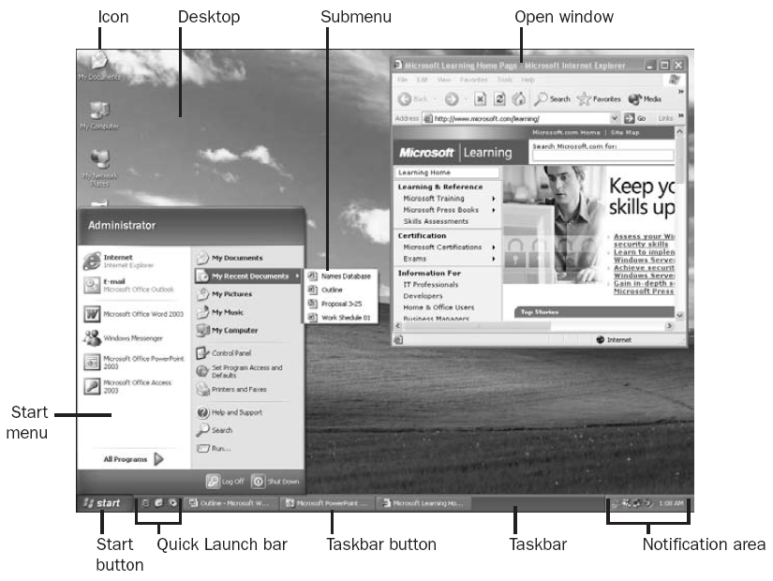

* + 1. 文件浏览窗口（Open Window）

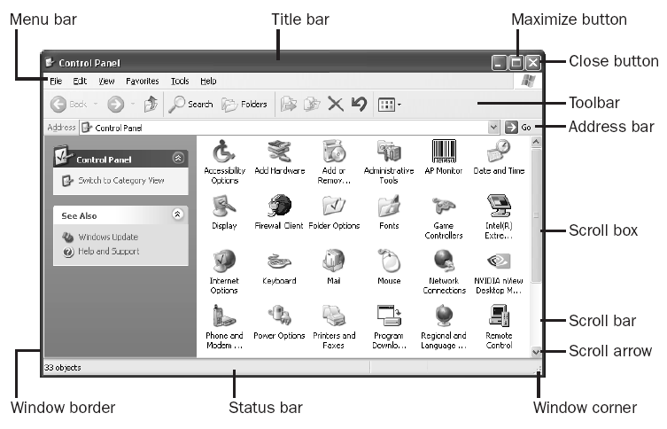

窗格：是窗口的一部分，仅用于一个划分的或单独窗口的独立区域。如：

Pane: As a part of a window, a pane is only used for an independent area in a divided or separate window.

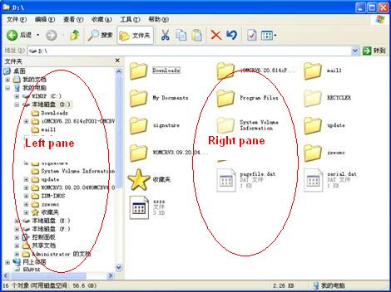

* + 1. 文档窗口（Document Window）

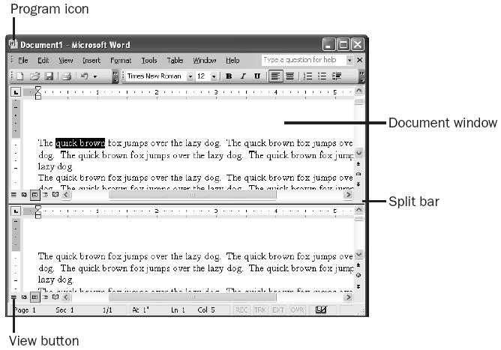

* + 1. 网页浏览器窗口（Web Browser Window）

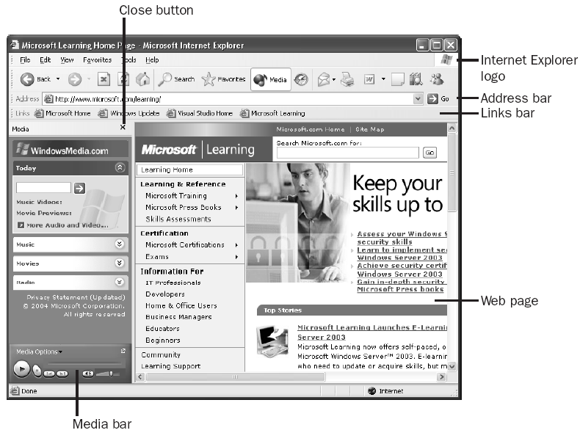

其中网页元素的命名如下：Elements in a Web page are named as follows:

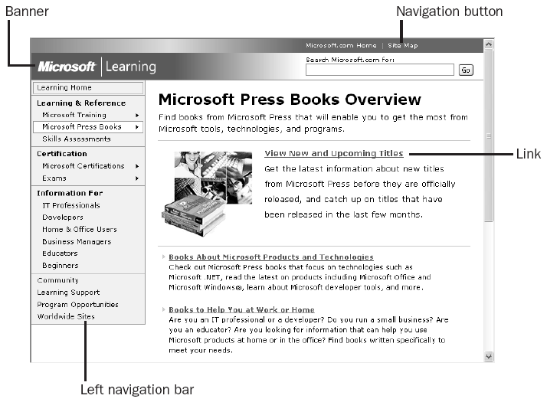

* + 1. 窗口元素Window Elements

菜单：Menu:

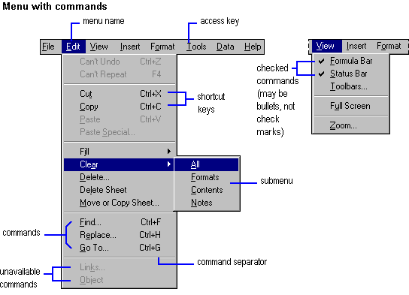

常用句型：(Recommended sentences:) Select A->B->C from the menu.

Select A->B->C.

下拉菜单 (Drop-down Menu)

单击菜单名向下弹出一列相关菜单项。

When the user clicks a menu name, a series of menus are displayed.

子菜单 (Submenu)

当用户选一个右边带小箭头的菜单命令时，出现的次级菜单。

When the user selects a menu with an arrow at the right of this menu, submenus are displayed.

快捷菜单 (Shortcut Menu)

单击鼠标右键出现的菜单。

When the user right-clicks one item, a shortcut menu is displayed.

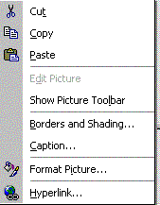

* + 1. 对话框常见界面元素Dialog-Box Elements

| **构成元素Element** | **定义 Definition** | **图示Icon** | **常用句型Recommended Sentence** |
| --- | --- | --- | --- |
| 命令按钮  Button | 矩形按钮，用来表示一个动作。如果一个命令按钮后面有省略号（3 个点），表示这个按钮会打开另一个对话框。完成这个操作以前还需要其他一些信息。  Rectangular button that initiates an action. A command button label ending with ellipses indicates that another dialog box will appear: More information is needed before the action can be completed. |  | 点击**XX**按钮，显示**xx**对话框，见图x-x。  Click **XX**. The **xx** dialog box is displayed, see Figure x-x.  Click the **XX** button. The **xx** dialog box is displayed, see Figure x-x.  注：对于对话框中常规位置的按钮（通常位于对话框的下方或右下方）或界面上显而易见的按钮，建议使用Click XX，不用Click the XX button. |
| 复选框  Check box | 方框，当选中或空时表示打开或者关闭一个选项。可以同时选择几个复选框。  Square box that is selected or cleared to turn on or off an option. More than one check box can be selected. |  | 勾选**XX**复选框  Select the **XX** check box.  清除某个复选框  Clear the **XX** check box. |
| 页签  Tab | 标记相关设置的组或多个选项。  Labeled group of options used for many similar kinds of settings. |  | 选择**XX**页签。  Click the **XX** tab.  注：Tab表示页签的整体，包含页签标题和其中的设置项，不使用Tab page。 |
| 文本框  Text box | 矩形框，用户可以输入文本。如果框中已经包含文本，用户可以选择缺省文本或删除已有文字，输入新文字。  Rectangular box in which the user can type text. If the box already contains text, the user can select that default text or delete it and type new text. |  | 在**XX**文本框里输入**xxx**。  Enter **xxx** in the **XX** text box.  Enter **xxx** in **XX**. |
| 下拉列表框  Drop-down list box | 带箭头列表框的闭合形式。当单击这个按钮时就会打开一个列表。  Closed version of a list box with an arrow next to it.  Clicking the arrow opens the list. |  | 在**XX**下拉列表框中选择**xxx**。  Select **xxx** from the **XX** list.  在下拉列表框中选择**xxx**。  Select **xxx** from the drop-downlist.  （注意：在正文中写到XX下拉列表框时，不需要加drop-down，仅用list就行。但是如果不写明XX，则要写drop-down list。） |
| 区域框(组框)  Group box | 外框或框，里面包含了一套相关的选项。  Frame or box that encloses a set of related options. |  | 在**XX**区域框中，选择**xxx**。  In the **XX** area, select **xxx**.  **原则：统一采用状语在前，动作在后的描述句型。** |
| 复合框  Combo box | 带有一个列表框的文本框。该列表框永远可见。由于用户可以输入或者选择一个值，你需用“输入(enter)的来描述这个动作。  Text box with a list box attached. The list is always visible.  Because users can either type or select their choice, you can use **enter** to describe the action. |  | 在**XX**复合框中选择**xxx**。  Select **xxx** from the **XX** combo box.  在**XX**复合框中输入**xxx**。  Enter **xxx** in the **XX** combo box. |
| 下拉复合框  Drop-down  combo box | 复合框的闭合形式。它旁边有个按钮，当单击这个按钮时就会打开一个列表。  Closed version of a combo box with an arrow next to it.  Clicking the arrow opens the list. | Snap2 | 在**XX**下拉复合框中选择**xxx**。  Select **xxx** from the **XX** drop-down combo box.  在**XX**下拉复合框中输入**xxx**。  Enter **xxx** in the **XX** drop-down combo box. |
| 下拉箭头  Drop-down arrow | 箭头，与一个下拉复合框，或列表框或某些工具栏按钮放在一起，表示用户点击这个箭头就可以看到一个列表。  Arrow associated with a drop-down combo or list box or some toolbar buttons, indicating a list the user can view by clicking the arrow. |  | 点击下拉箭头。  Click the drop-down arrow. |
| 标签  Label | 附加在任何选项、框、命令等上的文字。  应该使用标签来称呼任何选项、框等元素。  Text attached to any option, box, command, and so on.  Refer to any option, box, and so on by its label. |  | - |
| 列表框  List box | 任何一种包含一列项目的框，用户可以在框中进行选择。用户不能在列表框中键入一个选项。  Any type of box containing a list of items the user can select. The user cannot type a selection in a list box. |  | 在**XX**列表框中选择**xxx**。  Select **xxx** from the **XX** list. |
| 选项按钮  Option button | 圆按钮，用于从一组选项中选择一个选项。这些选项是互斥的。  Round button used to select one of a group of mutually exclusive options. |  | 点击**XX**选项按钮。  Click **XX**.  Click the **XX** option button.  如果表示“选中”状态，不能加上button一词。If the **Portrait** option is selected, … |
| 游标  Slider | 标尺上的指示器，用于显示或者设置连续范围中的一个值，如速度、亮度或者音量。  Indicator on a gauge that displays and sets a value from a continuous range, such as speed, brightness, or volume. |  | 移动**音量**游标，使音量**变大**。  Move the **Volume** slider towards **High**. |
| 微调输入框  Spin box | 带有上下箭头的文本框，用户可以点击箭头来改变设定范围内的数值。用户也可以在框中键入一个有效的数值。  Text box with up and down arrows that the user clicks to move through a set of fixed values. The user can also type a valid value in the box. |  | 点击**开始**微调输入框的上/下箭头。  Click the up/down arrow of the **Start** spin box.  在**开始**微调输入框中输入**8:00**。  Enter **8:00** in the **Start** spin box. |
| 标题  Title | 对话框的标题。标题通常(但不总是)与打开它的命令名标题匹配。  Title of the dialog box. It usually, but not always, matches the title of the command name. |  |  |
| 展开按钮  Unfold button | 命令按钮，带两个“大于”符号，可以展开次级窗口以显示更多的选项或者信息。  Command button with two “greater than” signs (>>) that enlarges a secondary window to reveal more options or information. |  | 点击**XX**展开按钮。  Click **XX**.  Click the **XX** button.  Click **XX**. |

注：“构成元素”的名称是图形界面的专业术语，有些是不为读者所熟知的，不必要向读者传递这些知识，因此有些是不推荐在文档中采用的。

Note: Element names are terminology on GUIs. Some element names are not familiar to users and it is unnecessary to tell them to users, so they are not recommended in manuals.

* + 1. 基于Web的中兴软件界面元素Web Page Elements of ZTE Software

下图显示了一个典型的Web界面。每种颜色指示一种元素。

The following figure shows a typical Web page, where each color indicates one element.

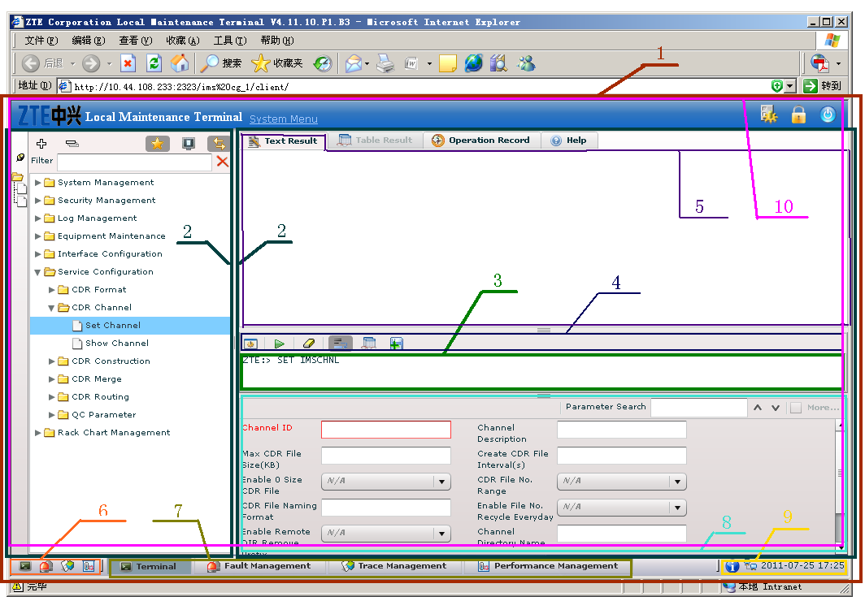

Web界面上的元素如下表所述。For elements on the Web page, refer to the following table.

|  |  |  |  |
| --- | --- | --- | --- |
| **序号No.** | **中文常用名**  **Chinese Name** | **描述**  **Description** | **英文**  **English Name** |
| 1 | 页面 | 输入地址后打开的窗口，不是指网管的功能视图（如**Terminal**）。  Page displayed after an address in entered in the address bar of a browser, which is not a function view (such as **Terminal**) in the NMS. | Web page |
| 2 | 窗格 | 略 | Pane |
| 3. | 命令输入框 | 人工输入命令的文本框，引导符不能删除、修改。Text box for manually entering commands, where | Command box |
| 4 | 命令工具栏 | 命令相关工具栏，包括切换命令模式、执行命令、清除命令输入框等。  Command-related toolbar, including switching command modes, executing commands, and clearing commands. | Command toolbar |
| 5 | 页签、页面 | 略 | Tab |
| 6 | 快速启动栏 | 可启动的功能包括命令终端、告警管理、跟踪管理和性能管理。  Includes starting **MML Terminal,** **Fault Management**, **Trace Management**, and **Performance Management** windows. | Quick launch bar (of the NMS)  网络管理系统 |
| 7 | 任务栏 | 类似于Windows的任务栏。  Similar to the taskbar of Windows. | Taskbar (of the NMS) |
| 8 | 参数设置区 | 设置参数的区域。  Area where parameters are set. | Parameter setting area |
| 9 | 状态区域 | 类似于Windows的状态区域。  Similar to the status area of Windows. | Status area (of the NMS) |
| 10 | 视图/分视图/窗口/页面 | 不含6、7、9的1；即网管的功能视图。该图例显示的是命令终端Terminal。Fault Management、Trace Management和Performance Management已运行，但没有当前显示。  1 excluding 6, 7, and 9, that is, function views of the NMS, including **MML Terminal**, **Fault Management**, **Trace Management**, and **Performance Management** windows. | Window |

## 常见界面术语辨析Differences Between Common Interface Terms

* + 1. Screen

If a displayed item is a screen then it must always be referred to as a screen and not a page or dialog box.

当整个屏幕都显示某个界面时，该界面要称为screen。

* + 1. 窗口（Window）与对话框（Dialog Box）的区别Differences Between Windows and Dialog Boxes

窗口与对话框有以下区别：

* 窗口有菜单栏，但对话框没有。  
  A window has a menu bar, while a dialog box does not.
* 对话框不能改变大小，而窗口一般都可以进行最大化和最小化等操作。  
  The user cannot change the size of a dialog box, while the user can minimize and maximize a window.
* 一般而言，当屏幕显示一个对话框时，对文档窗口的其他操作将不起作用，直到该对话框关闭为止。  
  In general, when a dialog box is displayed, the user cannot do any operation on the document window until the dialog box is closed.
  + 1. 对话框（Dialog Box）与信息框（Message Box）的区别Differences Between Dialog Boxes and Message Boxes

对话框与信息框有以下区别：

* 对话框需要用户做出相应，有双向的信息交互；而信息框是单向的。A dialog box solicits a response from the user.
* 对话框一般有关闭按钮，而信息框没有。A dialog box has a close button, while a message box does not.
* 信息框不支持内容输入或修改，而对话框一般支持。The user can enter or modify parameters on a dialog box instead of message box.

## 界面元素前常用介词搭配（Prepositions）

in the window

in the dialog box

on the screen

on the web page

on the tab

in the right pane

from the menu

on the toolbar

from the drop-down list

in the **Proxy Server** area

under IP address (在IP地址设置项下)

in the lower left part/corner of the window

on the right side of the window

# 标点符号 (Punctuation and Space)

## 中英文标点符号转换约定（Conversion of C-E Punctuation）

中英文标点符号转换约定如下：

| **中文符号** | **英文符号** | **备注** |
| --- | --- | --- |
| 顿号 、 | 逗号 , | - |
| 书名号 《》和〈〉 | 斜体 | 用于表达文档名称 |
| 句号 。 | . | - |
| 省略号 …… | … | - |
| 全角冒号 ： | 半角冒号 : | : 作为分隔符时，后面不用加空格。例如：时间17:18 |
| 全角括号 （） | 半角括号 () | - |
| 全角逗号 ， | 半角逗号 , | - |
| 全角分号 ； | 半角分号 ; | 尽量少用分号。 |

标点符号使用注意事项：

句号、问号、叹号、逗号、分号和冒号不出现在一行之首。

引号、括号、书名号的前一半不出现在一行之末，后一半不出现在一行之首。

破折号和省略号中间不能断开。

## 常用标点符号（Common Marks）

常用符号及其英文读法请见下表。正文中一般不使用符号（计算公式除外）表达英文意思，而优先使用英文words描述以方便读者理解。

For common marks and their pronunciations, refer to the following table. In general, you should prefer words to marks (except formulas) in the body.

运算符号前后需要加空格，括号及表示除法的/除外。A space is required before and after a mark (except parentheses, square brackets and /(meaning a division sign)).

|  |  |  |
| --- | --- | --- |
| **符号** | **中文** | **英文** |
| . | 句号 | Period |
| : | 冒号 | Colon |
| , | 逗号 | Comma. It is always correct to add a *comma* before *and* in a series of three or more items. Serial comma is also important in complex lists for readers to understand a statement faster. Example: A, B, C, and D. |
| ; | 分号 | Semicolon |
| ! | 惊叹号 | Exclamation mark |
| ? | 问号 | Question mark |
| - | 连字符 | Hyphen。 在Arbortext Editor中，按一下数字键盘上的减号。用于连接两个单词，组成复合词。也可以填到空的单元格里面。填到空的单元格里面。  Use a hyphen to indicate an empty cell in a table. |
| — | 长破折号 | Em dash，用法相当于中文中的破折号。常用在界面图名中，用于区分同标题图的不同功能界面。  在Arbortext Editor中，按两下数字键盘上的减号。In a figure title, it is used to separate GUI title and its tab name or function. |
| – | 短破折号 | En dash。用于表示：  • 数值范围(包含端值),前面不加from或between。数值含负号时,不用en dash,用through(包含端值)。段落文字中不使用en dash表示范围,使用between…and…(不包含端值)或from…through…。  •负号  •构成复合词作定语，如Windows NT-based program、 dialog box–type options、MS-DOS–compatible products （其中MS-DOS用的仍是连字符）(连字符)  两边不加空格。表格中的空单元格不使用En dash，使用连字符。表示范围时，只需在第二个数值后面加上单位符号。  在Arbortext Editor中，按三下数字键盘上的减号。  Shorter than an em dash and slightly longer than a hyphen.  Use an en dash:  • To indicate a range of numbers such as inclusive values, dates, or pages.  Do not mix text and en dash, as in “The voltage is from 42–48 V” (Use “from 42 V to 48 V” instead). For ranges, only add the unit after the second value, for example, 2–5 Mbps  Correct :  © 1993–1994  pages 95–110  • To indicate a minus sign  • To indicate negative numbers: –79  • To form a compound modifier for a noun, such as Windows NT–based program, dialog box–type options, MS-DOS–compatible products (MS-DOS still uses a hyphen)    Do not use an en dash to indicate an empty cell in a table. Use a hyphen instead.  Do not use spaces on either side of an en dash. |
| ' | 所有格符号 | Apostrophe |
| ‘ ’ | 单引号 | Single quotation marks |
| “ ” | 双引号 | Double quotation marks |
| ( ) | 圆括号 | Parentheses |
| [ ] | 方括号 | Square brackets |
| < > | 尖括号 | Angle brackets or chevrons |
| { } | 大括号、花括号 | Curly brackets |
| ... | 省略号 | Ellipsis |
| / | 斜线号 | • Slash  • Is divided by. Use * instead except when （除号）necessary. No space is required before or after it. |
| & | “和”符号 | Ampersand = and |
| + | 加号；正号 | • Plus. A space is required before and after it. If used in a key combination, no space is required before or after it, for example, Ctrl+A.  • Positive sign. No space is required after it. |
| - | 减号；负号 | • Minus. A space is required before and after it.  • Negative sign. No space is required after it. |
| ± | 加减号 | Plus or minus. No space is required before or after it. |
| × | 乘号 | Is multiplied by. A space is required before and after it. For example, 2000 mm × 600 mm × 600 mm. |
| ÷ | 除号 | Is divided by. A space is required before and after it. |
| = | 等于号 | Is equal to. A space is required before and after it. |
| ≠ | 不等于号 | Is not equal to. A space is required before and after it. |
| ≡ | 全等于号 | Is equivalent to. A space is required before and after it. |
| ≌ | 等于或约等于号 | Is equal to or approximately equal to. A space is required before and after it. |
| ≈ | 约等于号 | Is approximately equal to. A space is required before and after it. |
| < | 小于号 | Is less than. A space is required before and after it. |
| > | 大于号 | Is greater than. A space is required before and after it. |
| ≥ | 大于或等于号 | Is greater than or equal to. A space is required before and after it. |
| % | 百分之 ... | Percent |
| ‰ | 千分之 ... | Per mill |
| ∞ | 无限大号 | Infinity |
| √ | 平方根 | Square root |
| X2 | X的平方 | X squared |
| X3 | X的立方 | X cubed |
| Xn | X的n次方 | nth power of X, or, X to the power of n |
| Œ | 因为 | Because |
| ∑ | 总和 | (Sigma) summation of |
| ′ | 分 | Minute |
| ″ | 秒 | Second |
| # | ... 号 | Number |
| @ | at 标记 | At |

## 并列句末的标点符号（Parallel at Sentence End）

句式保持统一，都用短语或完整句子。

句末的标点符号统一，都用或者都不用标点符号。

如果是短语，句末都不用标点符号。

如果是完整的句子，句末都用句号。

Use the same format, all using phrases or sentences.

Use the same mark or no mark at the sentence ends.

If phrases are used, use no mark at the sentence ends.

If sentences are used, use periods at the sentence ends.

【举例】

Example:

The MPA has the following functions:

* Amplifying FR signals
* Detecting input, output and reverse powers

## 表格中的标点符号Marks in Tables

表格单元格的内容，如果是短语，句末都不用标点符号。

For phrases in cells of a table, use no mark at sentence ends.

如果是完整的句子，句末都用句号。

For sentences in cells of a table, use periods.

# 数字表达 (Digital Expression)

1. 在数字和单位之间加一个空格。如：80 km

角度的度数和机架的高度单位U除外。如：90°，1U。

2. 正文描述中，个位数（1到9）的数字要用英文单词拼写出来，10以及10以上的数字用阿拉伯数字表示（Write out numbers one through nine.） 。

3. 地址

935 W. Harding

4．时速

5 mph 225 mph

5．时间

3:15 A.M.

6．日期

采用阿拉伯数字，年月日可以采用计算机编程中统一使用的日期表达法表示：YYYY-MM-DD，月和日为个位数时，要加“0”补充，例如：2010-01-25

注：美式英语是“月-日-年”的顺序，英式英语是“日-月-年”的顺序，为避免混淆，采用计算机编程中统一使用的日期表达法（YYYY-MM-DD），适用的情况下也可采用January 25, 2010的格式。

7. 货币值

$45 $2 million

8. 测量单位

14’ 63/4” 16 mm 10 v

9. 在句首不使用数字

Incorrect:

568 people were fired last August.

Correct:

Five hundred and sixty-eight people were fired last August.

10. 系列数字的表达

We attended four meetings over a 16-day period.

11. 数字和字词结合

The worker needed six 2-inch nails.

12．百分比

25 percent 75 percent

13. 小数的单位

使用全称单位时，小于1的小数其单位用单数，大于1的小数其单位用复数，如0.5 second、1.1 seconds. 数字0的单位用复数，如0 seconds.

# 产品名称（Product Name）

英化时，产品名称需与公司规定的产品命名保持一致。查询产品命名，请访问公司网站：plm.zte.com.cn，点击 PDM产品数据管理 -> 产品管理 -> 产品项目 -> 产品分类浏览，按产品线展开查看即可。

During writing English manuals, use ZTE-defined product names. Visit the plm.zte.com.cn website to query a product name.

# 国际通用单位制 (SI)

一般采用国际通用单位。如果产品项目组要求，可在保留国际通用单位的基础上增加要求的制式单位，且公制单位应放在主导地位。

注：国际通用单位制，International System of Units (SI)，是由国际计量大会（CGPM）采纳推荐的一种一贯单位制。

Use International System of Units (SI) in ZTE documentation. Other systems can be added if the customer requires or the project team insists.

缩写单位无复数形式，即单、复数相同。如果使用全称，则应根据数量词采用单复数。泛指数量单位而无数量词的时候用复数，如“Unit: seconds”。

## 英文计量单位和科技术语及缩写（Measurement）

常用英文计量单位和科技术语及缩写：

| **英文 Term** | **中文** | **缩写 Unit** |
| --- | --- | --- |
| absolute | 绝对温度 | abs |
| alternating current | 交流电 | AC |
| American wire gauge | 美国线规 | AWG |
| Ampere | 安培 | amp |
| Ampere-hour | 安培小时 | amp-hr |
| amplitude modulation | 调幅 | AM |
| angstrom unit | 埃（长度单位） | A |
| atmosphere | 大气压力 | atm |
| atomic weight | 原子重量 | at wt |
| audio frequency | 音频 | AF |
| azimuth | 方位 | az |
| barometer | 气压计 | bar |
| barrel | 桶 | bbl |
| billion electron volts | 十亿伏特 | BeV |
| biochemical oxygen demand | 生化需氧量 | BOD |
| board foot | 板英尺 | bd ft |
| Brinell hardness number | 布氏硬度值 | BHN |
| British thermal unit | 英热单位 | Btu |
| Bushel | 蒲式耳（容量单位） | bu |
| Calorie | 卡路里 | cal |
| Candela | 堪（亮度单位） | cd |
| Celsius | 摄氏 | C |
| center of gravity | 重心 | cg |
| centimeter | 厘米 | cm |
| circumference | 圆周 | cir |
| cologarithm | 余对数 | colog |
| continuous wave | 连续波 | CW |
| cosine | 余弦 | cos |
| cotangent | 余切 | cot |
| cubic centimeter | 立方厘米 | cc |
| cubic foot | 立方英尺 | cu ft (or ft2) |
| cubic feet per second | 立方英尺/秒 | cfs |
| cubic inch | 立方英寸 | cu in. (or in.3) |
| cubic meter | 立方米 | cu m (or m3) |
| cubic yard | 立方码 | cu yd (or yd3) |
| current (electric) | 电流强度 | I |
| cycles per second | 周/秒 | CPS |
| decibel | 分贝 | dB |
| decigram | 分克 | dg |
| deciliter | 1/10公升 | dl |
| decimeter | 分米 | dm |
| degree | 度数 | deg |
| degree Celsius | 摄氏度 | °C |
| decagram | 十克 | dkg |
| decaliter | 十升 | dkl |
| decameter | 十米 | dkm |
| diameter | 直径 | dia |
| direct current | 直流电 | DC |
| dozen | 一打 | doz (or dz) |
| dram | 特拉姆（衡重单位） | dr |
| electromagnetic force | 电磁力 | emf |
| electron volt | 电子伏特 | eV |
| elevation | 海拔 | cl (or elev) |
| equivalent | 当量 | equiv |
| Fahrenheit | 华氏温度 | F |
| farad | 法拉（电容单位） | F |
| faraday | 法拉第（电量单位） | f |
| feet, foot | 英尺 | ft |
| feet per second | 英尺/秒 | ft/sec |
| fluid ounce | 液量盎司 | ft oz |
| foot-candle | 尺烛光（照度单位） | ft-c |
| foot-pound | 尺磅（功的单位） | ft lb |
| frequency modulation | 调频 | FM |
| gallon | 加仑 | gal |
| gallons per day | 加仑/天 | GPD |
| gallons per minute | 加仑/分钟 | GPM |
| grain | 微粒 | gr |
| grams | 克（米制质量单位） | g (or gm) |
| gravitational acceleration | 重力加速度 | g |
| hectare | 公顷 | ha |
| hectoliter | 百公升 | hl |
| hectometer | 百米 | hm |
| Henry | 亨利（电感单位） | H |
| Hertz | 赫兹 | Hz |
| high frequency | 高频 | HF |
| horsepower | 马力 | hp |
| horsepower-hours | 马力-小时 | hp-hr |
| hour | 小时 | hr |
| hundredweight | 英担 | cwt |
| inch | 英寸 | in. |
| inch-pounds | 英寸-磅 | in.-lb |
| infrared | 红外线 | IR |
| inner diameter or inside diameter | 内径 | ID |
| intermediate frequency | 中频 | IF |
| international unit | 国际单位 | UI |
| joule | 焦耳 | J |
| Kelvin | 绝对温标 | K |
| kilocalorie | 大卡（热量单位） | kcal |
| kilocycle | 千周 | kc |
| kilocycles per second | 千周/秒 | kc/sec |
| kilogram | 千克 | kg |
| kilohertz | 千赫 | kHz |
| kilojoule | 千焦耳（功的单位） | kJ |
| kiloliter | 千升（容量单位） | kl |
| kilometer | 千米，公里 | km |
| kilovolt | 千伏特 | kV |
| kilovolt-amperes | 千伏特安培 | kVa |
| kilowatt-hours | 千瓦-小时 | kWH |
| Lambert | 朗伯（亮度单位） | L |
| latitude | 维度 | lat |
| length | 长度 | l |
| linear | 线性 | lin |
| linear foot | 直线英尺 | lin ft |
| liter | 公升 | l |
| logarithm | 对数 | log. |
| longitude | 经度 | long. |
| low frequency | 低频 | LF |
| lumen | 流明（光通量单位） | lm |
| lumen-hour | 流明-小时 | im-hr |
| maximum | 最大数 | max |
| megacycle | 兆周 | mc |
| megahertz | 兆赫 | MHz |
| megawatt | 兆瓦特 | MW |
| meter | 米，公尺 | m |
| microampere | 微安培 | mA |
| microinch | 微英寸 | uin. |
| Microsecond | 微秒 | usec |
| microwatt | 微瓦特 | uw |
| miles per gallon | 每加仑汽油可行驶英里数 | mpg |
| millibar | 毫巴 | mb |
| millifarad | 毫法（电容单位） | mF |
| milligram | 毫克 | mg |
| milliliter | 毫升 | ml |
| millimeter | 毫米 | mm |
| millivolt | 毫伏 | mV |
| milliwatt | 毫瓦 | mW |
| minute | 分钟 | min |
| nautical mile | 海里 | NM |
| negative | 负数，负值 | neg |
| number | 号码，编号 | no. |
| ounce | 盎司 | oz |
| outside diameter | 外径 | OD |
| parts per billion | 十亿分之一 | ppb |
| parts per million | 百万分之一 | ppm |
| Pascal | 帕斯卡（压力单位） | pas |
| positive | 正数，正值 | pos or + |
| pound | 磅 | lb |
| pounds per square inch | 磅/平方英寸（压力标志） | psi |
| pounds per square inch absolute | 磅/平方英寸（绝对压力） | psia |
| quart | 夸脱(容量单位) | qt |
| radio frequency | 射频 | RF |
| radian | 弧度 | rad |
| radius | 半径 | r |
| resistance | 电阻 | r |
| revolution | 旋转 | rev |
| revolution per minute | 每分钟转速 | rpm |
| root mean square | 均方根 | RMS |
| second | 秒 | s (or sec) |
| secant | 正割 | sec |
| specific gravity | 比重 | sp gr (or SG) |
| square foot | 平方英尺 | ft2 |
| square inch | 平方英寸 | in2 |
| square meter | 平方米 | m2 |
| square mile | 平方英里 | mi2 |
| tablespoon | 大汤匙 | tbs (or tbsp) |
| tangent | 正切 | tan |
| teaspoon | 茶匙 | tsp |
| temperature | 温度 | t |
| tensile strength | 拉伸强度 | ts |
| ton | 吨 | t |
| ultra high frequency | 超高频 | UHF |
| vacuum | 真空 | vac |
| very high frequency | 甚高频 | VHF |
| volt-ampere | 伏安 | VA |
| volt | 伏特 | V |
| volts per meter | 伏特/米 | V/m |
| volume | 体积 | vol |
| watt-hour | 瓦特时 | whr |
| watt | 瓦特 | W |
| wavelength | 波长 | WL |
| weight | 重力，重量 | wt |
| yard | 码 | y (or yd) |
| year | 年 | y (or yr) |

* 1. SI前缀（SI Prefix）

| **Factor 系数** | **前缀 Prefix** | **符号 Symbol** |
| --- | --- | --- |
| 1024 = (103)8 | yotta | Y |
| 1021 = (103)7 | zetta | Z |
| 1018 = (103)6 | exa | E |
| 1015 = (103)5 | peta | P |
| 1012 = (103)4 | tera | T |
| 109 = (103)3 | giga | G |
| 106 = (103)2 | mega | M |
| 103 = (103)1 | kilo | k |
| 102 | hecto | h |
| 101 | deca | da |
| 10-1 | deci | D |
| 10-2 | centi | C |
| 10-3 = (103)-1 | milli | M |
| 10-6 = (103)-2 | micro | µ |
| 10-9 = (103)-3 | nano | N |
| 10-12 = (103)-4 | pico | P |
| 10-15 = (103)-5 | femto | F |
| 10-18 = (103)-6 | atto | A |
| 10-21 = (103)-7 | zepto | Z |
| 10-24 = (103)-8 | yocto | Y |

# 键盘按键约定

所按的按键加粗显示，首字母大写。组合键用+号连接，且+号前后无空格，例如：

For "press xxx” (xxx refers to a key or a combination of keys), names of keys to be pressed, separated by the + character, are shown in bold, for example:

Press **Ctrl+F4** to disable or enable this function.